Mini Test 6

Name : ____________________

Question 1
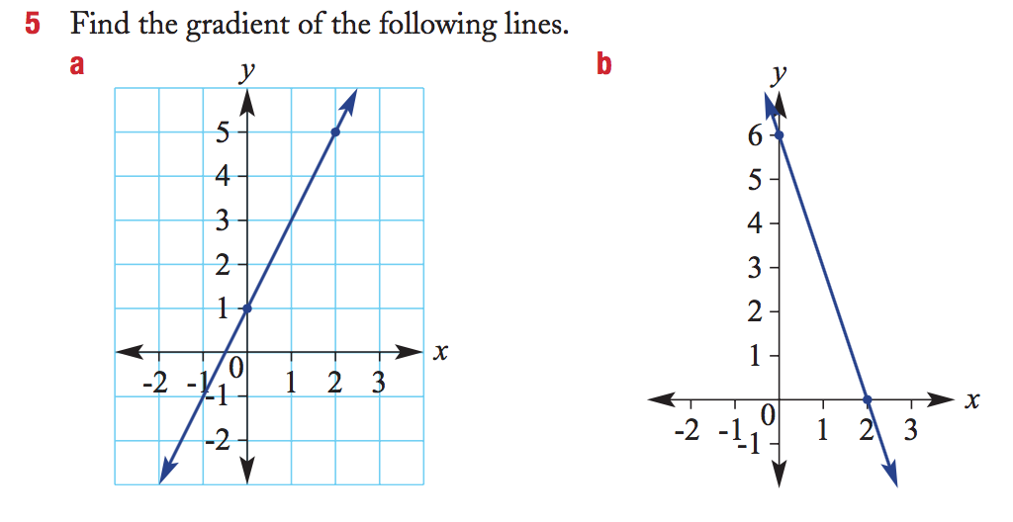
Question 2
Plot a line with a gradient of 5 that goes through the point (1, 4)
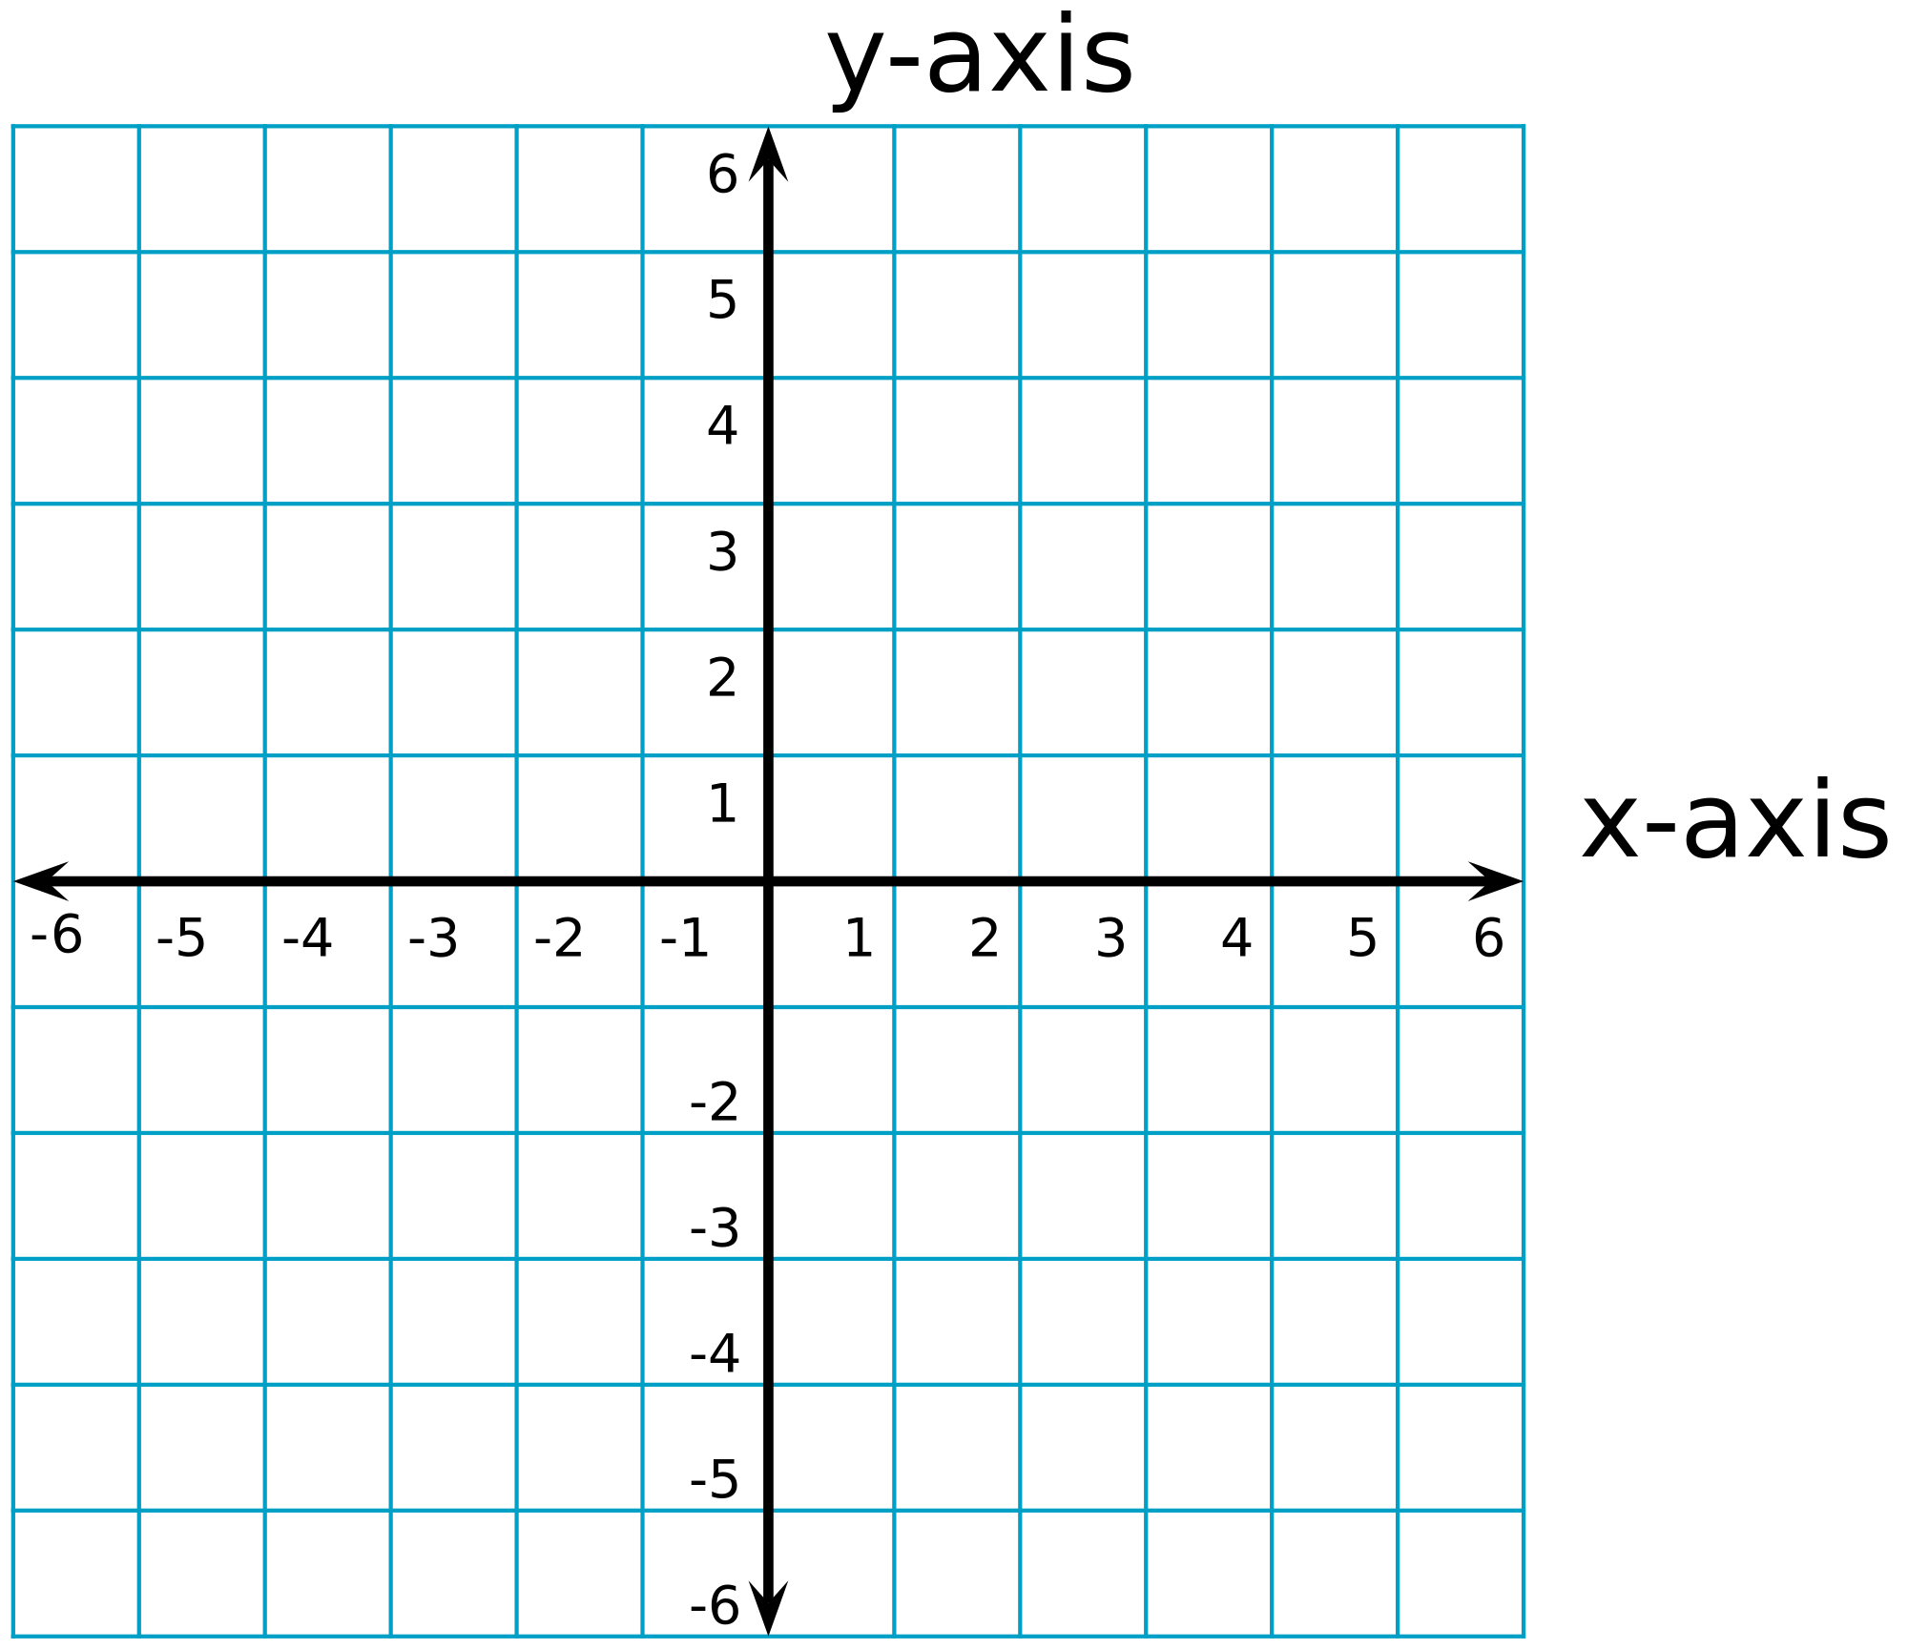

Mini Test 6

Name : ____________________

Question 1

Question 2
Plot a line with a gradient of 5 that goes through the point (1, 4)


Question 3
Find the gradient of the lines joining the following pairs of points.
a A(2, 3) and B(3, 5) b C(1, 2) and D(3, -4)

Question 4
- Determine the equation of the straight line with the gradient -2 and y-intercept =-2

- Determine the equation of the straight line with the gradient 5 passing through (0,6).

Question 5
What is the equation of this lines?

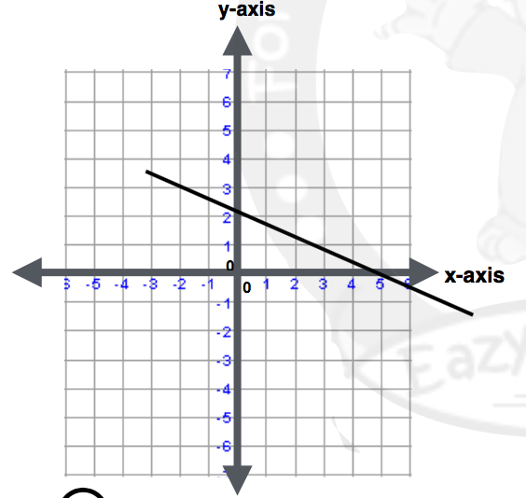
Question 3
Find the gradient of the lines joining the following pairs of points.
a A(2, 3) and B(3, 5) b C(1, 2) and D(3, -4)

Question 4
- Determine the equation of the straight line with the gradient -2 and y-intercept =-2

- Determine the equation of the straight line with the gradient 5 passing through (0,6).

Question 5
What is the equation of these lines?



